**Spring 2020 – INFOG6255 Selenium Project:**

**Requirements:**

1. Use **Maven** as your project and add dependency in your **pom.xml**.

2. Take **screenshots** after every step is successfully executed and save them in a folder with its

**scenario name**.

3. After a scenario is executed next scenario is run automatically without a manual intervention

4. Create a HTML report of the scenarios with the following columns:

* Test scenario name
* Actual
* Expected
* Pass/Fail

**Note:**

1. The above mentioned HTML report is one way of generating a report, if you can think of something else you can implement it.
2. Make sure you don’t get 2 factor authentication during presentation
3. Choose **any 3** test scenarios out of 5. (**If you choose scenario 1 then scenario 2 is not an option**)

**Team Presentations:**

1. Each group will be called randomly to present their script.
2. Your presentation should not be more than 10 minutes maximum.
3. Select one representative from your group that will demo the script in the class.
4. Your script should run seamlessly without any interruptions or manual intervention during the presentation.
5. All of the group members have to directly participate in the presentation and be ready to answer any questions.
6. For the online presentation, the group speaker will be given the Webinar control to showcase their script. Other questions may be asked of other team members during the presentation.

**Test Scenarios:**

**Scenario 1: Add options in “My Favorites” and verify if it works or not**

1. Login to My NEU portal
2. Add items to My Favorites

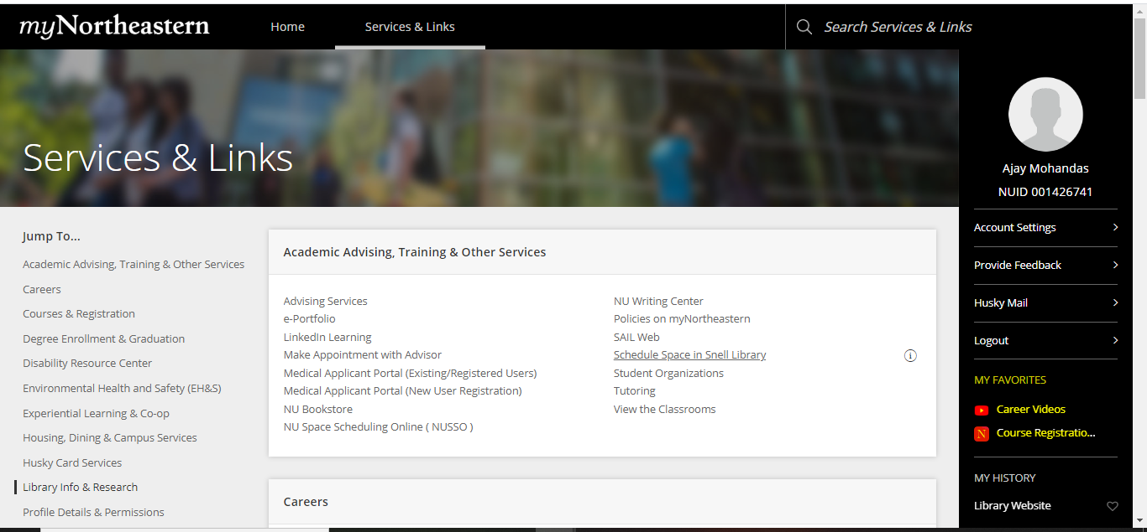

Note: The highlighted part is “My Favorites” section.

**Scenario 2: Verify if users can delete options from “My Favorites”**

1. Login to My NEU portal
2. Delete items from My Favorites



**Scenario 3: Verify if users can browse classes for Full Summer 2020**

1. Login to My NEU portal
2. Go to Course Registration
3. Browse classes for full summer 2020

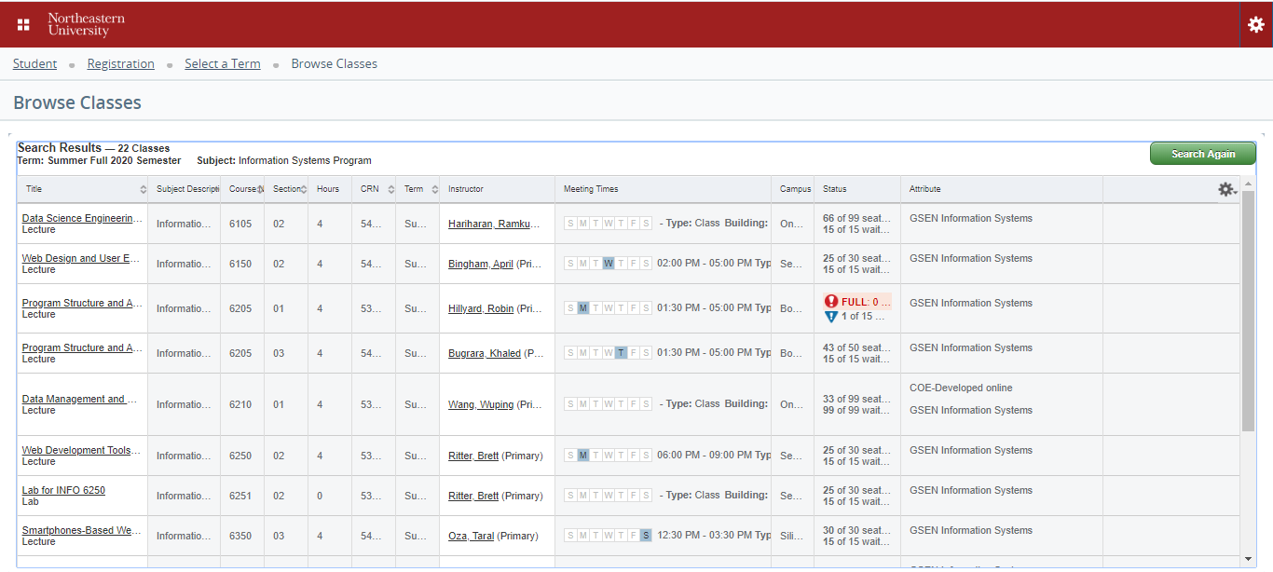

**Scenario 4: Verify if users can successfully add items to cart in NU Bookstore**

1. Login to NU bookstore
2. Search an item
3. Add item to cart
4. View the cart

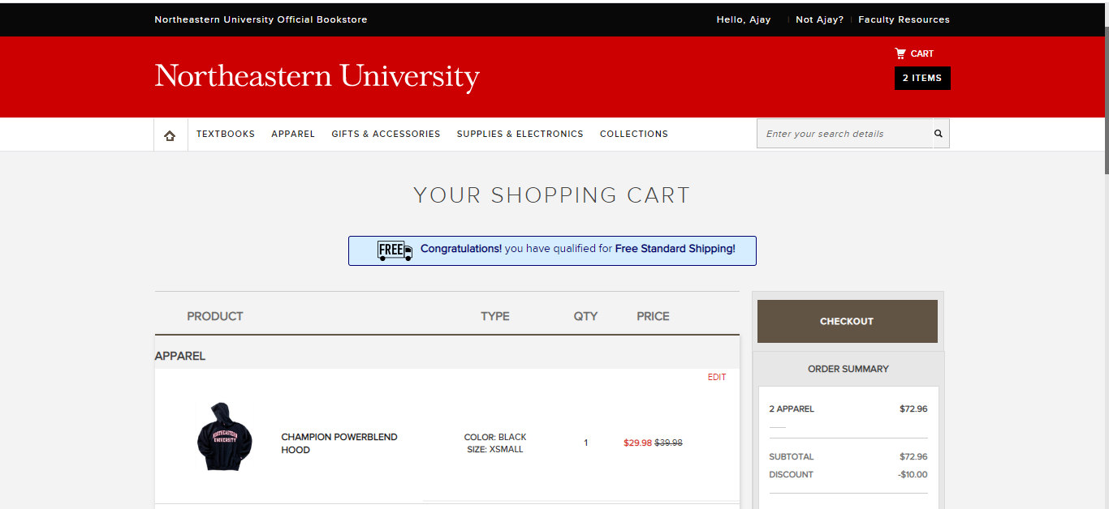

**Scenario 5: Verify if users can create a plan for course registration**

1. Login to My NEU portal
2. Go to Course Registration
3. Select “Plan Ahead” and select summer course
4. Create plan

